Round the traps: upcoming events and issues – ICYMI - #2
List edited by Dr Chloë Mason chloemason89@outlook.com
Mob 0419 811 750 Feedback welcome. Fri 22 July 2022.

The 2021 State of the Environment report (SOER) – “shocking”
Read it here: soe.dcceew.gov.au … Read the report. Make an impact. Heal Country.
Under the EPBC Act s516B, an SoE Report must be prepared every 5 years (uses pressure-state-response model). Principal co-author Prof Emma Johnston gave it to then Minister in October 2021, released 19 July 2022…
- National Press Club: 19 July Minister Tanya Plibersek (Environment and Water) Transcript: https://minister.dcceew.gov.au/plibersek/speeches-and-transcripts/national-press-club-address-minister-environment-and-water-tanya-plibersek Recording with questions: https://iview.abc.net.au/show/national-press-club-address [until 18 August].

- Min Plibersek 6 min statement to ABC News: https://www.youtube.com/watch?v=VPgUnAgnO30 [6000 views}
Here, refers to weed species now more that native plants – why matters? Agriculture expends $8.3bn weed control. Minister refers to Samuels (collaboration with States and business) also Matters National Environmental Significance (MNES) [definitions at: https://lawhandbook.sa.gov.au/ch19s02s02.php]

- Principal author Prof Emma Johnston with co-authors The Conversation – Grim and bright spots
https://theconversation.com/this-is-australias-most-important-report-on-the-environments-deteriorating-health-we-present-its-grim-findings-186131

Emma with co-author panel at Sydney Ideas: Wild weather, lost land and persistent pollutants.
Recorded for catchup: https://www.sydney.edu.au/engage/events-sponsorships/sydney-ideas/2022/emma-johnston-state-of-the-environment.html

Co-authors Dr Terri Janke, a Wuthathi/Meriam woman and an international authority on Indigenous cultural and intellectual property; the chair of the Western Australian Biodiversity Science Institute, leading environmental scientist, Dr Ian Cresswell; and Dr Sarah Hill, CEO of the Western Parkland City Authority.

CSIRO comment: Indigenous authors front and centre – first time in a SOER - entire Indigenous-led theme, Indigenous co-lead authors on most chapters, and Indigenous-specific case studies.
https://ecos.csiro.au/indigenous-authors-front-and-centre-of-latest-state-of-environment-report/

- Australian Academy of Science statement:
https://www.science.org.au/news-and-events/news-and-media-releases/statement-regarding-state-environment-report

- ACF Briefing – 21 July – Jess Abrahams National Coordinator, Maria Poulos Conkin Parliamentary & Political Relations Manager, Phoebe Rountree Mobilisation Coordinator. Zoom, incl Tein McDonald. 290 participants.
  - Trend on everything decline except air quality
  - Land is not “lost” rather destroyed, sealed under asphalt, concrete, plastic – challenge to Feds to meet 30% by 2030; tiny env flows to Murray-Darling… no surprises.
  - Good news: salties coming back from brink; 20 species turned around; connected to UN SDGs i.e. link to international commitments; Businesses starting to account for national capital.
  - ACF view of solutions: more funding; strong laws to protect habitat from destruction and invest in recovery; independent EPA; slash carbon emissions. Question about climate trigger for EPBC, given Living Wonders initiative… premature with reform EPBC Act
  - ACF Promotions: actions for members, Citizen Science: the platy-project, seize the moment!

- Greater Glider now listed as endangered https://www.abc.net.au/news/2022-07-06/greater-glider-listed-as-endangered-climate-change-logging/101212272
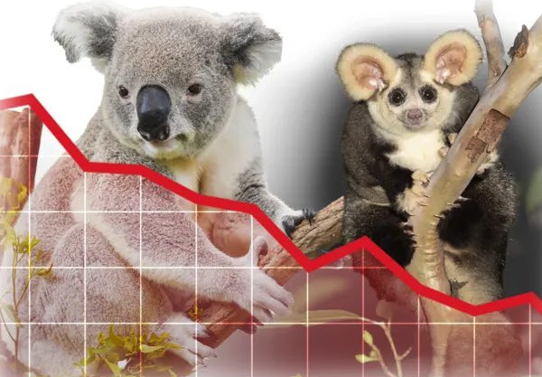
- Climate Council focuses on climate impact assessment in reforming EPBC Act and publishes letter in support of Living Wonders [Round the Traps #1]
https://www.climatecouncil.org.au/open-letter-to-minister-environment/

- Mainstream Media extensive coverage and social media (Twitter) – my pick

  - Adam Morton Guardian “The dire state of the environment report is a major challenge for Labor – and an opportunity’ 20 July 2022 asking:
    - Will the new EPA have investigative powers that reach into what have traditionally been state responsibilities? And what happens to the Morrison government plan – recommended by the Samuel review – to push even more decisions that affect the environment down to the states and territories?
    - Sitting above all this is the big question of how new laws will deal with the climate crisis. For more than 20 years, there has been debate about whether the EPBC Act should include a “climate trigger” – a test of the climate impact of fossil fuel projects.
https://www.theguardian.com/environment/2022/jul/20/the-dire-state-of-the-environment-report-is-a-major-challenge-for-labor-and-an-opportunity?CMP=share_btn_tw&s=09

- Prof David Lindenmayer The Age – SOER – forests - fire
“The bottom line is that salvage logging operations should be halted immediately. Today. The Victorian government has the power to do this. The elevated fire risks in Victorian forests are already alarming and the problem must not be even further magnified.”
https://www.theage.com.au/national/victoria/the-state-government-is-increasing-our-bushfire-risk-right-now-20220715-p5b1zu.html

- Noting Victorian cases about logging, and upcoming Vic elections, June ABC article helpful:
https://www.abc.net.au/news/2022-06-04/native-logging-ban-impact-on-forestry-families-and-timber-supply/101118870?t=cwqGAXNoTOWvRvvkkTXa9A&s=09

- Financial journalist Alan Kohler The New Daily tackles priority of climate that has evident impact on Australia’s SoER – three things Energy Minister must do:
https://thenewdaily.com.au/finance/finance-news/2022/07/21/chris-bowen-priorities-emissions-alan-kohler/

United Nations Decade on Ecosystem Restoration 2021-2030

“with the aim of supporting and scaling up efforts to prevent, halt and reverse the degradation of ecosystems worldwide and raise awareness of the importance of successful ecosystem restoration” UN General Assembly resolution A/RES/73/284:
https://documents-dds-ny.un.org/doc/UNDOC/GEN/N19/060/16/PDF/N1906016.pdf?OpenElement

Focus on Rivers
- SOER reports, ACF notes, that only 2 of 450 gigalitres were returned to the Murray-Darling River system – better protection is a declaration of the Minister.

- A new Australian doco: Following the Flow about the Macquarie River:
https://followingtheflow.com.au/about/
“The film shows a river detached from its natural ability to self-regulate, completely in the hands of humanity… the filmakers met with people – people with a passion for it: historians, First Nations people, ecologists, small business owners, water managers, farmers and fishers all with a story to tell… It set out to tell the story of the river, shaped by humans, but instead found the story of humans shaped by the river.”
Sunday 21 August 6pm, Golden Age, Sydney screening with Q&A director Nicholas Allen and narrator Jed Coppa (urban geographer, spatial scientist, amateur historian)
https://www.ourgoldenage.com.au/film/following-the-flow-q-and-a

- An American NW project on dead urban streams being restored and reconstructed: “To revive a river, restore its liver!” Learning about the ‘hyporheic zone’ from Erica Gies in Scientific American:
https://www.scientificamerican.com/article/to-revive-a-river-restore-its-hidden-gut1/

Upcoming

30 July National Tree Day and planting grasses!
Helping people to become involved, locally: http://treeday.planetark.org/site/10025941
Grassy Plains Network: https://grassyplains.net.au/

2022 National Landcare Conference Tues 23 to Thursday 25 August 2022
Darling Harbour, Sydney
Landcare Australia: https://landcareaustralia.org

ACT Inquiry into Environmental Volunteerism
Publication of transcripts of public hearings –ACT Legislative Assembly’s Standing Committee on Environment, Climate Change and Biodiversity: for transcripts. Highlighted multi-agencies, and staffing issues (rangers).[ NB AABR submission]
https://www.parliament.act.gov.au/parliamentary-business/in-committees/committees/eccb/inquiry-into-environmental-volunteerism#tab1917409-3id

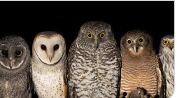

For children, 0-6 years

Jumping Joeys, Marsupials of Australia
http://sarahallen.com.au/shop/jumpingjoeys?t=UmJt6_mSSYZyf9xVi_vZjw&s=09

