Round the traps: upcoming events and issues – ICYMI - #8
List edited by Dr Chloë Mason chloemason89@outlook.com
Mob 0419 811 750 Feedback welcome. Tuesday 10 January 2023
This digest series – Round the Traps – is produced for the Restoration Decade Alliance in Australia: https://restorationdecadealliance.org/ supporting the UN Decade on Ecosystem Restoration aims “to halt the degradation of ecosystems and restore them to achieve global goals, for the benefit of people and nature”.
In 2023, UN Secretary-General Antonio Guterres says let’s put peace at the heart of our words and actions. Let’s share his hope that in the new year, peace will be restored to people’s lives, homes & across the whole world, for his video message in English.

20 December 2022 adoption of Global Biodiversity Framework:
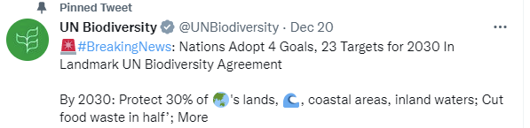
The documents: https://www.cbd.int/conferences/2021-2022/cop-15/documents

This historic accord is shadowed by “colonial injustice” expressed most forcefully by DRC and Uganda given the costs for them of protecting ecosystems.

December was a busy month, finishing both climate change and biodiversity COPs:
- During COP27, the Canberra Times reported on a new alliance to increase the global area of mangrove habitat by 20 per cent by the year 2030 to absorb significant amounts of carbon and reverse biodiversity loss. Australia’s joining was announced by the incoming Climate Change Ambassador Kristin Tilley replacing James Isbister formerly Environment Ambassador: https://www.dcceew.gov.au/about/news/new-ambassador-for-climate-change
For more on mangroves, including a case study from Adelaide on heavy metal pollution, see Monogabay’s Top Mangrove News for 2022 and ecosystem restoration in the Maldives for shoreline protection, support by Red Cross/Red Crescent: https://twitter.com/ICRC_nd

- “What does the historic agreement to establish a ‘loss and damage’ fund at this United Nations Climate Change Conference (COP27) in Egypt mean for small island developing states, particularly in the Pacific?” For the Asia & The Pacific Policy Society, ANU scholars’ podcast

- UNEP and the Secretariat of the Convention on Biological Diversity promoted communication of the IPBES assessment report that it had been invited to prepare. IPBES - Intergovernmental Science-Policy Platform on Biodiversity and Ecosystem Services – is not a UN body, but an independent intergovernmental body established by States to strengthen the science-policy interface for biodiversity and ecosystem services for the conservation and sustainable use of biodiversity, long-term human well-being and sustainable development, and effectiveness of responses.
- The pinnacle of COP15 was the Kumming-Montreal Pact, regarded as comparable to the Paris Agreement for climate, with targets, and calling for elimination or redirection of environmentally harmful subsidies to fund the commitments for protection and recognition of indigenous people as guardians of local ecosystems. At the end December, Elizabeth Mrema [@mremae] from the Secretariat of CBD was appointed as Deputy Executive Director UNEP. Commentary from Canadian academics relevant to Australia:
‘Extractivism’ is destroying nature: to tackle it COP15 must go beyond simple targets
- Oceans: for the largest area of the Earth, the oceans,

  - Professor Guy Standing (Centre for Post-capitalist Civilization) asks Can Cop15 protect ocean biodiversity from the big fish of the ‘blue economy’?

  - Pew Trusts reported on the momentum building to halt commencement of seabed mining in international waters.

  - The Australia Institute Tasmania convened an Ocean Summit – from “global to local, for the ocean we want” – size, First Nations protection & production (“blue economy”, law …).

On Australian policy development

On COP15, lead environmental journalist, Guardian Australia’s Lisa Cox provided helpful commentary: COP15 what does the Kumming-Montreal Pact mean for Australia’s land, sea and threatened species? She describes the need for funding, to support Pacific nations, and quotes Invasive Species Council James Trezise who points out that targets of the agreement are interlinked: to protect habitat Australia also needed to manage major threats [major pests].

On 8 December, as awaited before the year’s end, Minister Plibersek announced the Labor government’s response to the Samuel Report, the two-year-old statutory review of the Environment Protection and Biodiversity Conservation Act (EPBC Act) commissioned by the previous government, together with the 2021 State of the Environment Report. The response sets out the government’s commitment to reform Australia’s environmental laws to better protect, restore and manage our unique environment: Nature Positive Plan: better for the environment, better for business .

The last pages describe the next steps: an ongoing period of engagement with stakeholders, development of standards, discussion with the States. Legislation will be issued as an exposure draft prior to being introduced into the Parliament before the end of 2023.

For some commentaries:
- On the early announcement of Federal EPA, a new statutory decision-making body about major projects using national standards by Lisa Cox from the Guardian, while Adam Morton highlighted: https://www.theguardian.com/environment/2022/dec/11/labor-proposal-to-fix-australias-broken-environmental-protection-system-could-revolutionise-sector?s=09

- From the ANU College of Law, on 13 December in The Conversation Peter Burnett: https://theconversation.com/complete-elation-greeted-pliberseks-big-plans-to-protect-nature-but-hurdles-litter-the-path-196287 Among the hurdles are environmental offsetting and issuing of biodiversity credits that has run into difficulties, its plan to extend national environmental standards to Regional Forestry Agreements, and weasel words [a state-sponsoring green-washing by reliance on offsets in Bill Hare’s words of warning].

- A five-minute podcast: https://www.protectningaloo.org.au/in-the-media/

- To the Minister’s aim for “A target of zero new extinctions on this continent”,
ongoing news of development, 9 December was challenging Tasmanian windfarm approved despite concerns for threatened wildlife – Robbins Island, habitat for Tasmanian Devils and endangered Orange-bellied Parrots.
At December’s end, Humane Society International’s Nicola Beynon reported: “The national threatened species standard likely won’t be in place until sometime later next year. But if we’re going to stop extinctions we need to draw that line in the sand now, not wait for the standard to be agreed by parliament,” by Mike Foley SMH Plibersek faces 140 decisions pitting koalas against development Another example, reported earlier on 9 December

To the Minister’s recent budget expenditure ($1.8 billion), conservationists have estimated a cost of $26 billion. This budgetary discrepancy brings policy back to outsourcing to the private sector. Given Australia’s experience with water credits, carbon credits, Australia Institute’s Polly Hemming asked in The Saturday Pape 10 December: So why does the government think that putting a price on critically endangered wildlife habitats can help save them? Peter Garrett had some good rejoinders, while Senator Pocock expressed concerns that offsets and credits will just lock in the trajectory of species decline. More funding needed, he says and the courage to say no to further land clearing. NSW experience with biodiversity offsets has been dire, to be kept as last resort.
For reflections on “nature markets” published 10 years ago by Yale Environment: https://e360.yale.edu/features/ecosystem_services_whats_wrong_with_putting_a_price_on_nature

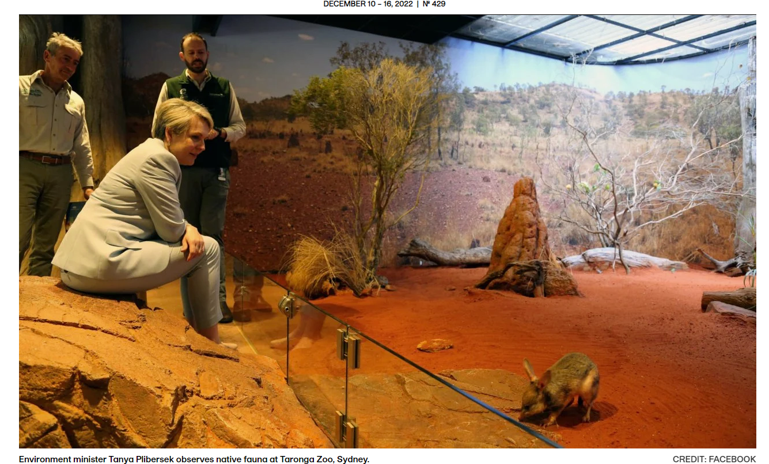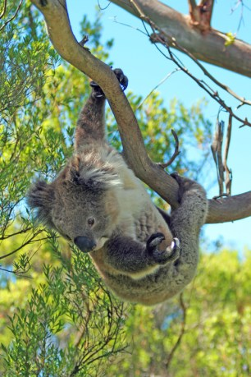
Hanging on: https://arr.news/2022/11/28/nsw-koalas-and-industrial-logging-of-the-public-forest-estate-sue-higginson/

Other Australian policy developments

Burning biomass and forests
Minister Bowen announced that native wood “waste”/biomass is no longer to be defined as ‘eligible renewable energy source’ for the purposes of [the nation’s] Renewable Energy Target, and electricity it generates cannot be used to create tradable Large-scale Generation Certificates [for replacing coal].” Following on from RTT #6, yay!

This decision was more significant than it may appear. Journalist Professor Justin Catanoso (Wake Forest University, USA) explains the consequences in his contribution to Mongabay (non-profit news from Nature’s frontline), briefly:
On December 15, Australia became the first major economy worldwide to reverse itself on its renewable classification for woody biomass burned to make energy….That decision comes as the U.S., Canada, Eastern Europe, Vietnam and other forest nations continue gearing up to harvest their woodlands to make massive amounts of wood pellets, in order to supply biomass-fired power plants in the UK, EU, Japan, South Korea and elsewhere.
In the EU, forest advocates continue with last-ditch lobbying efforts to have woody biomass stripped of its renewable energy designation and end the ongoing practice of providing large subsidies to the biomass industry for wood pellets.
Science has found that biomass burning releases more carbon dioxide emissions per unit of energy produced than coal. Australia’s decision, and the EU’s continued commitment to biomass, creates a conundrum for policymakers: How can major economies have different definitions of renewable energy when it comes to biomass?
‘Timber harvesting’ was recognised as a disturbance, along with grazing and land clearing, that contributes to declining soil organic carbon in a new report by the NSW Natural Resources Commission (website down) such that NSW forests could become net carbon emitters, as reported by the Guardian. Protests ramped up in the Bulga forest (NSW Mid-North Coast), reported by the ABC , by the people of the North East Forest Alliance, with supportive concerns by independent candidates for the NSW election in March.

On the last sitting day for 2022, the National Native Tribunal gave its approval:
‘Shameful day for Australia’: Santos given green light to drill 850 gas wells in native forest (that’s the Pilliga, Gomeroi Country).

In 2023 Australian policy will turn on native forests and the arboreal threats so well put for Greater Gliders in The Conversation earlier this year.

End Plastic Pollution! (UNEP/EA.5/Res.14)

It was pleasing to hear Minister Plibersek bring Australia saying: Plastic pollution is a global problem and it’s going to require global solutions. That’s why we’re delighted to join the High Ambition Coalition and the Global Commitment. We need to work hard and we need to work together. No one nation can solve the problem alone. Australia then caught up with the agreement reached in March by the UN Environment Assembly in Nairobi, Kenya: https://www.unep.org/news-and-stories/press-release/historic-day-campaign-beat-plastic-pollution-nations-commit-develop. The treaty calls for covering the “full life cycle” of plastics, since pollution in manufacturing, recycling and disposal is recognised at a crisis point with climate and nature.

After investigation of the voluntary scheme Alliance to End Plastic Waste (AEPW), based in Singapore reported by Bloomberg and its target failures, regulatory intervention is welcome particularly with new research on nanoparticles from plastic re-use (as on road surfaces) and human bodies published by the American Chemical Society.

LEGACY OF RESEARCH FOR ECOSYSTEM RESTORATION
Honouring innovative Australian ecologist Maisie Carr (nee Fawcett) for research on long-term effects on vegetation of grazing by cattle and deer in the high country.

In 1945, scientist Maisie Carr (nee Fawcett) erected a fence around 5 hectares of subalpine peatland on Victoria's Bogong High Plains. That fence would form the first of Maisie's Plots, two monitoring sites that are still used by scientists today, and have recently been added to the Victorian Heritage Register.

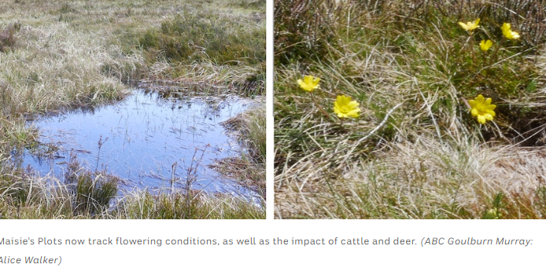

Another conservation story, brought to ABC by researchers, citizen scientists and volunteers helping restore habitat is heartening: penguins on Snapper Island off the NSW south coast.

FILM BLUEBACK – screening at Palace cinemas
Mia Wasikowska plays a marine biologist in the latest Australian film based on Tim Winton’s novel. Also starring Eric Bana with Nigel Westlake’s music.

Luke Buckmaster, Guardian’s film critic:
“While the film drifts around a bit, neither plot-driven nor super stylish, but it’s a nice, gentle kind of drift… there’s plenty of air in the frame and space for contemplation… a broadly appealing – if a little indistinct – experience that doesn’t speak down to younger audiences but certainly hands them unambiguous moral lessons.” The trailer: https://www.youtube.com/watch?v=w2qkfMAXQOM

While much of the cast is restrained, Radha Mitchell is fiery and passionate as the younger Dora, while Eric Bana’s small role as the Ocker fisherman Macka leaves a big impression. But it is underwater where ‘Blueback’ is breathtaking. https://scenestr.com.au/movies-and-tv/blueback-film-review-20230103

□□ □□ □□ □□ □□ □□
Suggestions welcome: chloemason89@outlook.com

