Round the traps: upcoming events and issues – ICYMI - #7
List edited by Dr Chloë Mason chloemason89@outlook.com
Mob 0419 811 750 Feedback welcome. 30 November 2022
This digest series – Round the Traps – is produced for the Restoration Decade Alliance in Australia: https://restorationdecadealliance.org/ supporting the UN Decade on Ecosystem Restoration aims “to halt the degradation of ecosystems and restore them to achieve global goals, for the benefit of people and nature”.

International governance: COPs
COP27 UN Climate Conference.
A qualified victory – no plan to get to 1.5˚C but recognition of consequences of climate change with the establishment of the ‘loss and damage” fund to support the most vulnerable countries, at long last. “In 1991, Vanuatu presented climate negotiators with a proposal to require wealthy nations to pay the poorer countries most affected by rising sea levels.” - Jonathan Pearlman, The Saturday Paper 2 December 2022.

- At this COP meeting. two traditional owners from the Zenadth Kes or Torres Strait told delegates of their fear for the islands. Previously, the UN Committee on Human Rights had found:
https://theconversation.com/australia-violated-the-rights-of-torres-strait-islanders-by-failing-to-act-on-climate-change-the-un-says-heres-what-that-means-191329?s=09
Here, in Australia, a landmark legal case is underway on the duty of care toward the islanders: ABC RN 18 November 2022 6 minutes.
- Regarding the COP, Martin Kaiser, Greenpeace Germany tweeted:
“At the end of #COP27 there is a small plaster stuck to a huge gash.
Relief fund for damages and losses, success of those affected. Phasing out of coal, oil and gas, prevented by the oil lobby.”
https://twitter.com/martinkaisergp/status/1594258345086566408?t=OQhfmvzpjmABXZXaL3meaA&s=09
- At the COP’s end, a good reminder in The Conversation from Prof Matt McDonald, professor of international relations, University of Queensland: Public mobilisation and activism, market forces, aid and development programs, and legislation at local, state and national levels are all important sites of climate politics – and potentially, significant change.

COP 15 to the Convention on Biological Diversity (Part Two), Montreal, 7-19 December 2022. Australia Institute’s Richard Merzian will be attending.

News of Australian policy development
Back in September, PM Albanese recognised the dual crises on signing the Leaders’ Pledge for Nature. Albanese said this “This highlights Australia’s reinvigorated approach to protecting our environment and climate leadership and signals our solidarity with other world leaders in our commitment to taking strong action on the dual crises of biodiversity loss and climate change.”
Introducing its webinar, the Australia Institute observed:
“Australian governments have committed to tackling the twin climate and biodiversity crises but continue to subsidise and approve fossil fuels and habitat destruction. While simple policy solutions exist, governments are instead relying on over-complicated market-based solutions to conceal the fundamental contradiction between support for fossil fuel production and promises to save the environment.” -
Offsetting Us Up To Fail: The myths of ‘nature markets’ explained 23 November 2022, YouTube https://www.youtube.com/watch?v=p1PEazodBls

On conservation and biodiversity:
- Lisa Cox 27 November 2022
Tangled mess of inaction - conservation planning and recovery plans in the run-up to the government’s response to the Samuel review of the EPBC Act

- Lisa Cox Guardian 24 November 2022 of NSW Legislative Council report Integrity of Biodiversity Offsets Scheme
found to be (surprise) trading away for cash threatened species for cash.

On carbon trading and regulation:
- Australia Institute’s Submission to Chubb Carbon Offsets Inquiry

on 18 November, consists of a letter and four attached reports (online), which have all been prominent in recent debate around Australian Carbon Credit Units (ACCUs) and the wider carbon credit system.

- On the Climate Change Authority, a statutory body mandated to give independent climate policy advice to government since 2011, see the review “Conflicted Authority” by Polly Hemming, The Saturday Paper, 2 December 2022.

Legal decisions of significance, include:

The Land Court of Queensland, President Fleur Kingham has recommended the state government reject the applications for a mining lease and environmental authority by Waratah Coal in central Queensland’s Galilee Basin because the proposal "risks unacceptable climate change impacts to Queensland people and property…” [para 36].
The Environmental Defenders Office, on behalf of Youth Verdict and The Bimblebox Alliance, opposed the mining lease on three related grounds: human rights damaged by potential consequences of climate change, carbon emissions, and destruction of nearby Bimblebox nature refuge.

An executive summary introduces the full judgement (372pp)
https://archive.sclqld.org.au/qjudgment/2022/QLC22-021.pdf
Setting up a sound foundation is apparent, as in para [5] clarifying the legal status of coal: This coal is a public source, owned by the State, to be exploited, or not, for the public good. There is no default position in favour of or against exploitation.
This case is regarded as making legal history, as Professor Justine Bell-James, Law School, University of Queensland explains for The Conversation: https://theconversation.com/this-case-has-made-legal-history-young-australians-just-won-a-human-rights-case-against-an-enormous-coal-mine-195350

Starting with climate change,
at para [24]: What is in dispute is whether I can take into account the emissions from combustion of the coal. Waratah says the Court has no control over the emissions… the emissions in generating electricity will be the responsibility of those countries and are not relevant to these applications.
at para [25]: However, granting permission to mine the coal cannot be logically separated from the coals being used to generate electricity. As a matter of law, I have decided to take the emissions into account in applying …
at para [35]: …1.58Gt of CO₂ is a meaningful contribution to the remaining carbon budget to meet the long-term temperature goal of the Paris Agreement. Making coal available for combustion could limit the options for achieving that goal.
The financial, economic, and social assessment follows. As Prof Bell-James explains, a major barrier to climate change litigation in Queensland has been the ‘market substitution assumption’ (if we don’t, someone else will). This decision rebuts that presumption.
For Bimblebox Nature Refuge, the executive summary describes Bimblebox and assesses the proposal to mine [paras 13,15,16,18-20, 38, 44]. Assessment of the proposal on Bimblebox [para 150ff] and offsets for Bimblebox, including the contested evidence of experts and the uncertainty are instructive [449-569].
Following up on Living Wonders …
Recalling this legal intervention for Environment Council of Central Queensland (RTP #1), Minister Plibersek agreed to the reconsideration request, brought by Environment Justice Australia (EJA). EJA put forward, and published online, an enormous body of evidence on the climate risk of fossil fuel proposals (16 coal and 2 gas) to thousands of significant animals, plants, and ecosystems/places under EPBC Act (‘MNES’). The Climate Council supports this intervention.
Among the proposals are Waratah Coal, to cover 144,000 hectares in the Galilee
Basin. Another is Idemitsu’s “extension” of its open cut mine Leard State Forest, Boggabri NSW, to extra 6 million tonnes per year with its estimated local climate cost put at just $300.
The Environmental Approvals Division of the Department of Climate Change, Energy, the Environment and Water (DCCEEW) invited public comment, principally on whether one shares the view, the test, that there is ‘substantial new information’ about carbon emissions that is ‘likely’ to have an impact on MNES. Thousands of people have made submissions in support of this legal intervention.

Some water news
Over twenty years, water has been turned into a commodity suited to trading.
Results of that experience may well presage the results for carbon and biodiversity. Last year Scott Hamilton surveyed the Australian water market for The Conversation:
ruing the domination by ‘robber barons and high speed traders’.

October saw the wettest month on record for the Macquarie Marshes, a RAMSAR wetland. The Sydney Morning Herald report on a field trip by biologists and students.
Climate change will sap the marshes of more water in coming years but, for the time being, water extraction is the main reason for the marshes’ downward trend. In 2009, the government notified Ramsar that the Macquarie Marshes were degrading from a semi-permanent wetland to an ephemeral wetland.
The number of [waterbird] nests counted over summer this year will give crucial insight into just how resilient this boom-and-bust ecosystem really is.

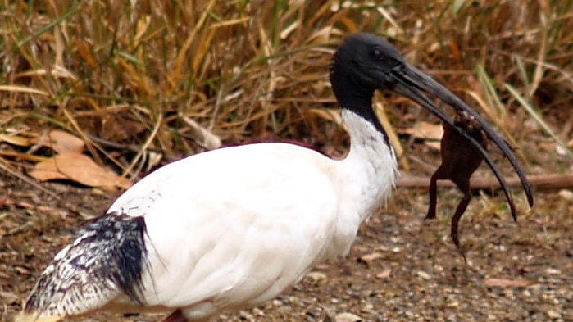
Credit: Photo published ABC, supplied: Liam Gill.

Speaking of Ibis, Emily Vincent as co-ordinator of Watergum's Cane Toads program explained how they are aiding the control of invasive cane toads. They now show a new learned behaviour, eating poisonous cane toads after subjecting them to stress and washing, suggested the toxins washed away suggests Prof Rick Shine Macquarie University, as reported by ABC Gold Coast 23 November 2022.
In the Northern Territory, the largest groundwater licence staged over 30 years will “extract more than 1 trillion litres of water from red dirt Kaytetye country, and according to the project's own estimations it could destroy up to 30 per cent of the region's groundwater-dependent ecosystems. Most groundwater dependent ecosystems in the area are sacred sites and their potential destruction is driving traditional owner opposition to the licence.” – granted for free. As reported by ABC News Alice Springs. Legal action in NT Supreme Court is underway by the Arid Lands Environment Centre. Since then, warnings by academics of NT’s lack of water planning and its failings in relation to the National Water Initiative were reported by ABC News this month.

Ecological restoration and conservation – good stories

‘Return to 1616’ ecological restoration project: translocation of Western Grasswren ABC 19 November 2022 news reporting on latest re-introduction of species for restoration of Dirk Hartog Island. A typically collaborative project between Bush Heritage Australia, WA Dept of Environment & Conservation, and UWA Saul Cowan and doctoral student Aline Gibson Verga. These rare wrens – known as Wirruwana by the Malgana People – were translocated from two distinct areas in Shark Bay. This project has been successful with re-introductions of marsupial species, driven to extinction by feral animals, and has generated some fine school resources for primary and secondary schools and academic literature. dever

Tasman Peninsula bush block Sloping Main Reserve
The ABC reported on the success of Tasmanian Land Conservancy (TLC) to purchase this 425-hectare bush block for $3.4million, through donations (539 donors) matched by the Elsie Cameron Foundation. Home to seven threatened vegetation communities, including a significant area of critically endangered black gum forest. 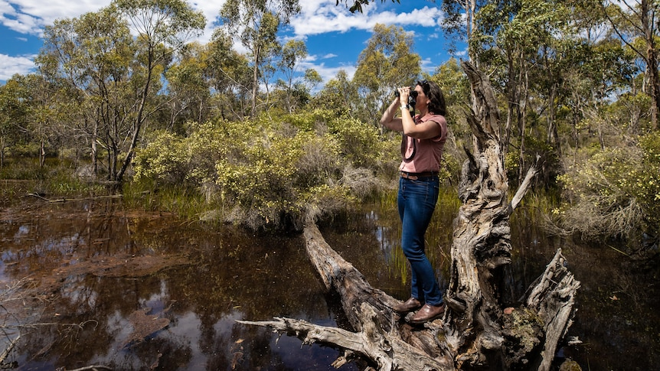

FILM – SONG – PHOTOGRAPHY – PRESENTS!
Arctic Sinkholes SBS on Demand.
Documentary 53m. Craig Secler and fieldwork scientists from University of Norway
Investigations of melting permafrost in Alaska releasing methane and sinkholes causing releasing of distinct, fossil methane. .

Voice of the Sea – a song by John Williamson, Australian music icon and as friend of Australian Marine Conservation Society. On YouTube with lovely marine graphic video.

New posters of frogs and invertebrates of Darwin and NT
From ecologist-photographers Nick Volpe and Lucyna Kania, NLWild:
https://www.nlwild.com/shop?s=09

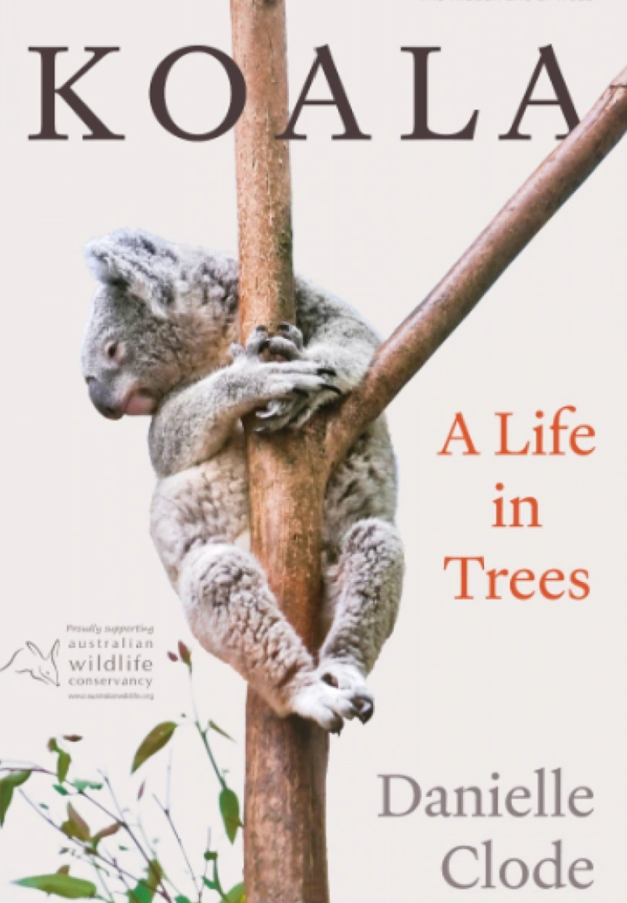 Well reviewed koala book.

Guide to the Creatures in Your Neighbourhood
https://www.urbanfieldnaturalist.org/book
Designers and scientists at UTS and Sydney Environment Institute, USYD, formed the Urban Field Naturalist Project with this book designed help people, all ages, to connect with nature – nature that’s on the doorstep, in the park and all around us.
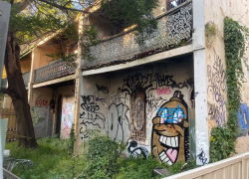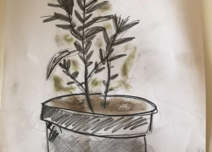
The Project is truly engaging: resources to get started Resources include count sheets, colouring-in sheets, an invitation to contribute stories with a template and these stories are published on the site. Above Lucy Cartwright’s The Mint Tree and Tom David’s The gaps we Leave. Listen to 3CR interview of two authors Zoe and Dieter cover reimagining the naturalist tradition, poetic sublime, wonder over data in citizen science, cultural storytelling for scientific engagement and more
□□ □□ □□ □□ □□ □□
Suggestions welcome: chloemason89@outlook.com

