Round the traps: upcoming events and issues – ICYMI - #5
List edited by Dr Chloë Mason chloemason89@outlook.com
Mob 0419 811 750 Feedback welcome. 30 September 2022
This digest series – Round the Traps – is produced for the Restoration Decade Alliance in Australia: https://restorationdecadealliance.org/ supporting the UN Decade on Ecosystem Restoration aims “to halt the degradation of ecosystems and restore them to achieve global goals, for the benefit of people and nature”.

International governance
The next Nature COP (distinct from Climate COP) starts in December in Montreal. Here’s a basic Explainer. What is Cop15 and why does it matter for all life on Earth?
https://www.theguardian.com/environment/2022/aug/30/what-is-cop15-and-why-does-it-matter-for-all-life-on-earth-aoe?CMP=Share_AndroidApp_Other

Comment on Australia’s Climate Council report about managing relations with Pacific neighbours: https://johnmenadue.com/environment-pacific-wants-australian-support-for-strong-climate-action-10-september-2022/

Political economy. Markets? Finance Sector. What place in environment protection and biodiversity?

In September, UN Secretary-General’s António Guterres told a high-level meeting in New York: I am calling on all developed economies to tax the windfall profits of fossil fuel companies…
https://thenewdaily.com.au/news/national/2022/09/26/anthony-albanese-optus-leak/

Minister Bowen described Australia being open for business for renewables, side-stepping the calls here to impose this tax for transfer to needed programs: Dr Ken Henry, Richard Denniss, and Garnaut. Watch for upcoming Revenue Summit, hosted by the Australia Institute.

UN Environment Programme (UNEP) - Finance Initiative https://www.unepfi.org/themes/ecosystems/nature-risk-no-longer-if-but-how-and-where/?s=09

Finance sector urges higher emissions reduction target!
https://www.theguardian.com/australia-news/2022/sep/28/australia-urged-to-adopt-75-emissions-reduction-target-by-2035-if-it-is-to-reach-net-zero?CMP=Share_AndroidApp_Other&s=09

Safeguard mechanism? – an explainer, because “in May, when the Albanese government was elected promising to make it a centrepiece of its pledge to ramp up climate action. But I suspect for most people, even those paying regular attention, the details are hazy.” Adam Morton, Guardian Australia’s climate and editor, 26 September 2022.
ACF says“the safeguard mechanism is core to the process of undoing the damage done by excess pollution. But like a champion forward who hasn’t scored a goal all season, the safeguard mechanism is a good instrument that is functioning poorly. “
https://www.acf.org.au/what-is-the-safeguard-mechanism

Analysis of market mechanisms in environment sector:
- Green Finance Observatory (northern hemisphere) An independent think tank working on carbon markets, natural & human capital and sustainable finance, says: “The forthcoming creation of new financial markets on environmental degradation, based on the idea that we need to put a price on nature to save it and that market-based solutions would succeed where traditional environmental policies have failed.” A claim.: https://greenfinanceobservatory.org/
- ABC reports: Industry bosses making money from carbon credits say system needs to change 6 September 2022.
- The Australia Institute’s executive director Richard Denniss on “Green Wall Street” in Australia – what value platypuses and their ecosystems:
The Australia Institute published a YouTube webinar on “Tanya Plibersek says it would cost $1 billion pa to save our endangered species…compared to the $500 million we just spent on the war memorial, our $11 bn per year of fossil fuel subsidies & the $250 bn for Stage 3 tax cuts it seems like a bargain #auspol”
https://www.youtube.com/watch?v=2Q4MAyHbGZY

Careful, then, with market instruments applied to environment! And greenwash! What alternatives? Watch for Revenue Summit before the budget!

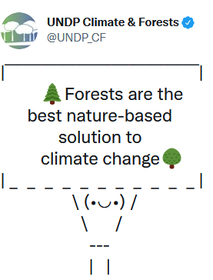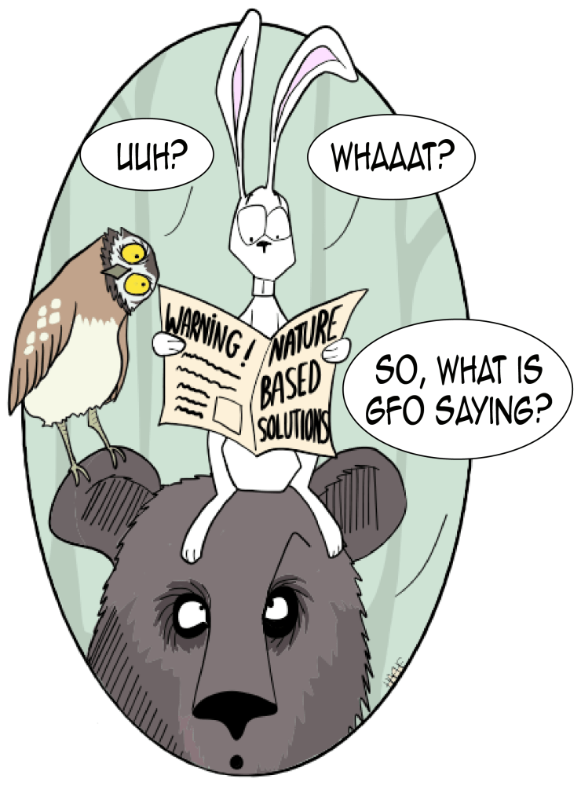

Historians of science publishing in Climate and Development respond to ‘the tragedy of climate change science’ with the plea, “Don’t gloss over social science! a response”
https://www.tandfonline.com/doi/full/10.1080/17565529.2022.2076647?src=recsys
A brief report of the despair expressed by New Zealand scientists is at: https://www.abc.net.au/news/science/2022-09-04/climate-change-ipcc-reports-scientists-withdraw-support/101357920

And in Queensland, the Energy & Jobs Plan for Queensland. QCC is also engaged with advocacy for Queensland government’s new $62 billion, 10 year Energy & Jobs Plan :https://www.abc.net.au/7.30/
Land clearing Qld gets ABC news coverage 29 September. Story brought by Queensland Conservation Council and Wilderness Society with comment by ecologists: https://www.abc.net.au/news/2022-09-28/questions-over-land-clearing-in-north-queensland/101478962
ICYMI – science news; educational materials

National Landcare Conference webinars: https://www.landcarer.com.au/blogs/melanie-hartley/2022/08/18/landcareconf22-education-resources

Australian Trees and their Ecosystems.
- ABC Catalyst collection of videos for school students, and interested adults: https://www.abc.net.au/education/collections/australian-trees-and-their-ecosystems/
- Do you know your eucalypts? ABC Quiz:

Tipping elements in climate science
- Potsdam Institute for Climate Impact Research, Developments in ‘Tipping Elements’ Science - great graphics: https://www.pik-potsdam.de/en/output/infodesk/tipping-elements/tipping-elements?s=09

- On this new study, a brief summary and commentary from the Guardian: https://www.theguardian.com/environment/2022/sep/08/world-on-brink-five-climate-tipping-points-study-finds
- More comment from Bill McGuire, professor emeritus of geophysical and climate hazards at UCL, and the author of Hothouse Earth: an Inhabitant’s Guide. His point: 1.5˚C has been a useful metric in the global heating story…but we mustn’t become obsessed with a single target figure. On the contrary, we need to knuckle down as much as we can to prevent every 0.1˚C rise…in order to rein in climate breakdown as best we can. You never know, we might just get lucky.
https://www.theguardian.com/commentisfree/2022/sep/12/global-heating-fighting-degree-target-2030

Bettongs and ferals’ exclusion
https://www.abc.net.au/news/2022-08-29/northern-bettong-numbers-crash-feral-proof-fence-starts/101371562

FILMS
Jed Coppa’s new documentary Following the Flow (the Lachlan River) now available on SBS On Demand.

Dr Joëlle Gergis, climate scientist at the ANU Fenner School of Environment and Society, comments on her new book Humanity’s Moment: A Climate Scientist’s Case for Hope in the Guardian, 10 September 2022.

□□ □□ □□ □□ □□ □□
Suggestions? chloemason89@outlook.com

