Round the traps: upcoming events and issues – ICYMI - #3
List edited by Dr Chloë Mason chloemason89@outlook.com
Mob 0419 811 750 Feedback welcome. 10 August 2022

On Sustainable Development Goals
https://www.nature.com/articles/s41893-022-00909-5
“Scientific evidence on the political impact of the Sustainable Development Goals” Frank Bierman & others, 20 June 2022, Nature Sustainability
“In 2015, the United Nations agreed on 17 Sustainable Development Goals as the central normative framework for sustainable development worldwide.

“…findings suggests that the goals have had some political impact on institutions and policies, from local to global governance. This impact has been largely discursive, affecting the way actors understand and communicate about sustainable development. More profound normative and institutional impact, from legislative action to changing resource allocation, remains rare. We conclude that the scientific evidence suggests only limited transformative political impact of the Sustainable Development Goals thus far.”

Responses Minister Plibersek National Press Club wide-ranging address covered many aspects of her portfolio for Environment and Water – international commitments (e.g. 30x30 by 2030) and her participation, the release of the 5 yearly SoER, the 10-yearly review of EPBC in the Samuel Report Final, water and the Murray-Darling water plan, the critical greater role of Aboriginal and Torres Strait Islander people, and local communities, everyone to curb the decline. It prompted many responses.

RDA member ACLA (Australian Land Conservation Alliance, Jody Gunn CEO) welcomed the Minister’s announcements, and her acknowledgement of the need for increased investment in protecting our environment. ACLA commented:
30x30
One positive step is confirmation of the government’s commitment to protect 30 per cent of Australia’s land and 30 per cent of Australia’s sea by 2030 (30x30). Private protected areas will be a critical part of achieving this target and the report outlines their current contribution.
Minister Plibersek’s reference to ALCA
Minister Plibersek noted in her address: “The Australian Land Conservation Alliance estimates that we need to spend over $1 billion a year to restore and prevent further landscape degradation.”
Australia’s declining natural environment parallels reduced investment in the environment and a lack of national coordination. Public and private investment will be critical to the task.

The work of ALCA, its members and private landholders fits squarely within this framework as is outlined in ALCA’s Strategic Plan: Protecting and stewarding for Nature.
Private landholders are building resilience across our land through protecting and restoring our unique ecosystems. Our members and the thousands of landholders they engage with are on the frontline of stopping biodiversity loss and regenerating landscapes. They are actively managing land, translocating species, tackling invasive species, revegetating and restoring.

The state of the environment report, through its co-design, recognised the role of Aboriginal and Torres Strait Islander people and local communities in land management and decision making in relation to nature and heritage.

The number of threatened species listed under the EPBC Act has risen for almost all taxa over the past 5 years.
Australia state of the environment 2021: biodiversity (dcceew.gov.au) p. 18

Minister Plibersek’s agenda
Minister Plibersek outlined the 3 goals that will underpin her agenda: to protect, restore and manage the Australian environment.

The Ministers words are promising. The Minister’s words, however, do differ from the UN resolution on ecosystem restoration: “to prevent, halt and reverse the degradation of ecosystems” (UN General Assembly Resolution). These capacities are spread across portfolios.

THE CONVERSATION –
- on international targets of 30x30 protected areas – terrestial and marine – for biodiversity by 2030 response from Benjamin Cooke (RMIT) , Aidan Davison(Utas), Jamie Kirkpatrick (Utas) and Lilian Pearce (La Trobe) 29 July 2022.
https://theconversation.com/protecting-30-of-australias-land-and-sea-by-2030-sounds-great-but-its-not-what-it-seems-187435?

- on participation of everyone. Kylie Soanes, School of Ecosystem & Forest Sciences, Uni Melb. 21 July 2022. Tips on local participation and encouraging others:
https://theconversation.com/yes-the-state-of-the-environment-is-grim-but-you-can-make-a-difference-right-in-your-own-neighbourhoood-187259?s=09
PlanetArk helped people become involved locally and celebrate National Tree Day 31 July by plantings: http://treeday.planetark.org/site/10025941
For example, in Lane Cove National Park, riverbank revegetated with community of plants, kids saw kookaburras for the first time learning that they eat worms, fish and sausages!

- on marine life fleeing equator to temperate waters, in context of marine history, food web dependence on plankton, and political economy. Anthony Richardson (UQ), Chavva Chaudhary(Auckland), David Shoeman (USC), Mark Costello (Auckland).
https://theconversation.com/marine-life-is-fleeing-the-equator-to-cooler-waters-history-tells-us-this-could-trigger-a-mass-extinction-event-158424

For RDA, this piece contributes to RDA’s central purpose:
The movement of commercial and artisanal fish and marine megafauna could compromise the ability of tropical nations to meet the Sustainable Development Goals concerning zero hunger and marine life. And Is there anything we can do?

- With the Ministerial commitment to respond to the Samuel Final Report on the review of the EPBC Act by the end of 2022, Prof James Watson (UQ) 22 July 2002 wrote: https://theconversation.com/labor-wont-overhaul-environment-laws-until-next-year-here-are-5-easy-wins-it-could-aim-for-now-184565?

- In relation to EPBC Act reform, Brendan Sydes (Law Uni Melb, previously CEO EJA) 2 August 2022:

https://theconversation.com/the-greens-climate-trigger-policy-could-become-law-experts-explain-how-it-could-help-cut-emissions-and-why-we-should-be-cautious-187998

- Darcy Watchorn, Luke Emerson (Deakin) on Greater Gliders, newly listed, yet hurtling towards extinction. Helpful analysis, from evidence to action:
https://theconversation.com/greater-gliders-are-hurtling-towards-extinction-and-the-blame-lies-squarely-with-australian-governments-186469?t=ohc5tj-RB00JL1rmUMYJRg&s=09

An international shortage, not merely baristas! Botanists are disappearing – just when the world needs them most: Sebastian Stroud (Univ Leeds UK) & others journal article was picked up in the mainstream media, here’s the source: Ecology and Evolution 10 July 2022, “The botanical education extinction and the fall of plant awareness” https://doi.org/10.1002/ece3.9019

Regulatory practice on pesticides – a question for trade
Why are pesticides banned overseas still used in Australia? Donna Lu Guardian 11
https://www.theguardian.com/australia-news/2022/jul/11/why-are-pesticides-banned-overseas-still-used-in-australia-and-what-does-it-mean-for-the-environment?CMP=Share_AndroidApp_Other

Decisions of ecosystem destruction being challenged

Graham Readfern, Guardian 26 July, highlights the EPBC approval was made in June by the new Minister Plibersek acting on departmental advice.
https://www.theguardian.com/australia-news/2022/jul/26/wa-ring-road-approved-by-federal-government-threatens-ancient-trees-and-endangered-wildlife

Major WA Supreme Court appeal to WA EPA’s decision, approving changes for Woodside’s Burrup Hub gas facilities on the NW Shelf. Such changes mean that the actual project has not had the full assessment of impacts on climate. The Burrup Hub on the Western Australian coastline is the biggest fossil fuel project in Australia’s history.
If it goes ahead, Woodside’s project would unlock two major new gas fields leading to the equivalent of an estimated 6 billion tonnes of carbon pollution, with annual emissions equal to those of New Zealand, Ireland, Norway and Bolivia combined.
The emissions from this development would further catapult global warming …Not only that, this massive gas hub would sit on the Burrup Peninsula/Murujuga – a rugged coastal region rich with unique wildlife and cultural history, which has been placed on the tentative World Heritage list but is being increasingly industrialised by projects like this. This is brought by EDO for Conservation Council of WA that has over 750 appellants.
https://www.edo.org.au/2020/12/21/supreme-court-challenge-over-australias-biggest-gas-project/
[Disclosure: conflict of interest, Chloë is among the 750 appellants.]
This action is complementary to the Living Wonders Legal Intervention on 19 coal and gas projects: https://livingwonders.org.au/explore-the-evidence/coal-and-gas/

Native forests – distressing scenes of habitats being bulldozed, usually subsidised by taxpayers, in all most States. e.g. https://www.canberratimes.com.au/story/7822112/spotlight-on-logging-as-marsupials-wane/?cs=14264
https://www.canberratimes.com.au/story/7822112/spotlight-on-logging-as-marsupials-wane/?cs=14264

Good news…
Bob Brown Foundation had a legal win in its efforts to protect Tassie Devils from becoming roadkill. To protect the Takanya forest, MMG (mining) must cease all work and the new minister, Tanya Plibersek, will need to start the assessment afresh to properly consider the Tasmanian Masked Owl.
Glenlee on the Georges River NSW has just been listed as a Local Heritage Item by Council (DOI: submission-writer].

Obituary for James Lovelock
- Helen Horton https://www.theguardian.com/environment/2022/jul/27/james-lovelock-creator-of-gaia-hypothesis-dies-on-103rd-birthday
- Irish John Gibbons, journalist and campaigner, gives a succinct summary of James Lovelock’s major contributions at the end of podcast of The Last Word on the Environment hosted by Matt Cooper on 2Day FM after discussing emissions reduction target by sectors in Ireland.

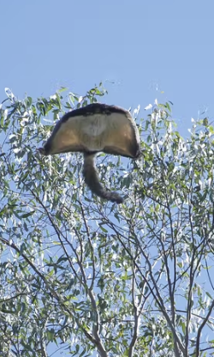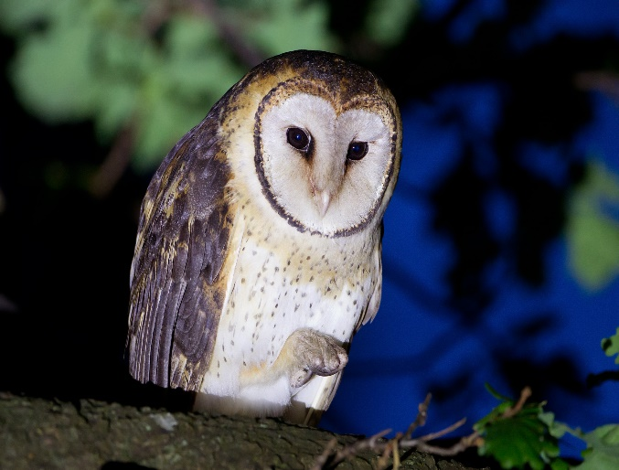

A/RES/73/284: https://documents-dds-ny.un.org/doc/UNDOC/GEN/N19/060/16/PDF/N1906016.pdf?OpenElement
https://www.iucn.org/crossroads-blog/202108/we-need-protect-and-conserve-30-planet-it-has-be-right-30

