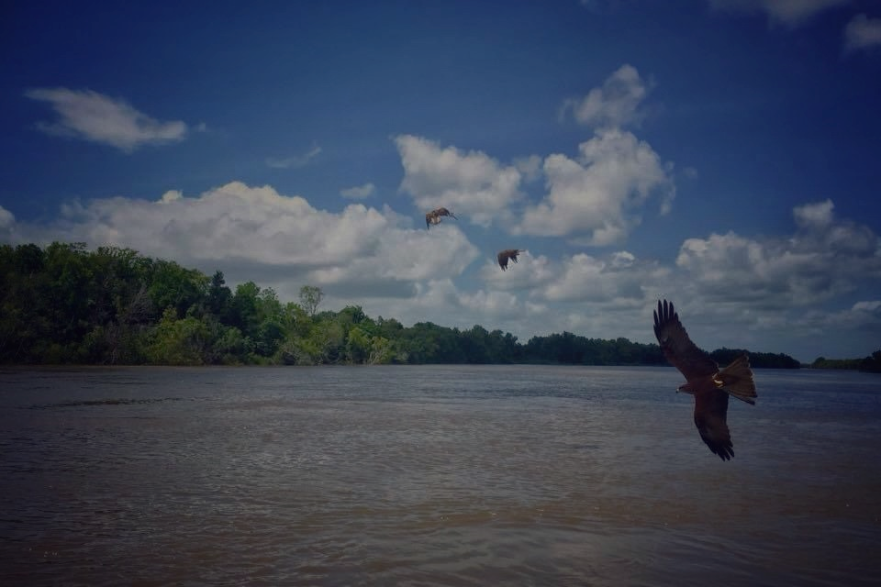
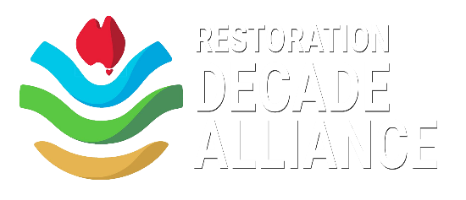
RDA Partnership Application Form

The Restoration Decade Alliance (RDA) is a network of Australia’s pre-eminent environmental organisations, united in our collective efforts to support the goals of the UN Decade on Ecosystem Restoration.
Partner organisations are organisations of good standing* whose core activity is not ecological restoration but which is sympathetic with, informs, or supports ecological restoration. Partners enhance the RDA’s reach and ensure the RDA is well-informed about relevant opportunities and constraints. Partners are not primarily focused on restoration but can include ecological societies, conservation networks, farmer groups, and ancillary support organisations.
Partner groups receive the following benefits:
- Opportunity to contribute to (and collaborate with) an important alliance of Australian restoration organisations (and all the benefits that collaboration could bring) e.g.:
  - promoting targeted action by Australian communities in the Decade
  - sharing best-practice knowledge
  - influencing national and state policies etc as a ‘single voice’;
- National amplification of a group’s stories and events through social media highlighting their role in meeting the goals of the UN Decade on ER;
- Receipt of RDA e-news (subject to funding);
- Email communication of any collective RDA campaigns and communication initiatives (as appropriate);
- Ability to use the RDA logo in promoting their projects that support the goals of the UN Decade on ER; and,
- Guest status at RDA meetings to which the group is invited (where relevant).
The RDA asks, in return, that the Partner (to the level suited to the Partner):
- Reciprocates sharing of opportunities for collaborative and synergistic action; and,
- Reciprocates sharing of information relevant to the Decade and pursuing its goals.

*The RDA Steering Committee reserve the right to review a Partner’s status at any time.

About your organisation

(a) Name of your organisation:

(b) What aspect of ecosystem restoration does your organisation focus on?
(c) What is your organisation’s vision/mission?
(d) What is your organisation’s geographic scale/reach?

2. Contact details and organisational information
(a) Primary contact name & email:

(b) Cc contact name & email:

(c) Comms contact name & email:

(d) Organisation website:

(e) Number of members in your organisation (or otherwise describe):

(f) Your organisation’s social media links:
Facebook:
Instagram:
Twitter:
TikTok:
LinkedIn:

3. Your organisation and the Restoration Decade Alliance (Up to 100 words per question)

- How do you see your organisation aligning with aspirations of the UN Decade on ER?

- Are there particular objectives your organisation would particularly like to achieve during the UN Decade on ER?

- How do you see your organisation’s Partnership of the RDA assisting you in achieving these objectives?

- How do you see your organisation’s Partnership assisting the RDA?

- Do you have any suggestions of activities the RDA could undertake (as an alliance)?

5. Any other information about your organisation that you would like to share:

- Completed applications to be emailed to facilitator@restorationdecadealliance.org -

