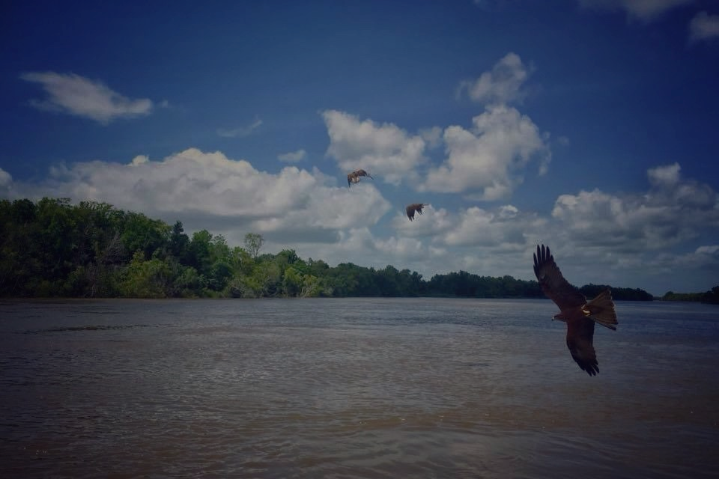
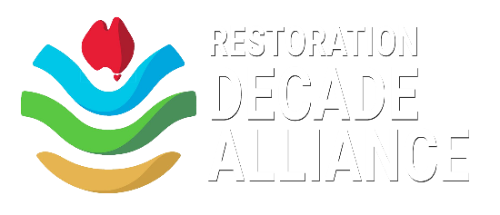
RDA Membership Application Form

The Restoration Decade Alliance (RDA) is a network of Australia’s pre-eminent environmental organisations, united in our collective efforts to support the goals of the UN Decade on Ecosystem Restoration. Member and Partner organisations represent various areas of expertise and work together for more effective, intersectional ecosystem restoration efforts and outcomes.

Member organisations are larger restoration groups of good standing* (non-profit or for-profit) whose core activity is the promotion and/or practice of ecological restoration.

Member organisations have an opportunity to contribute to, collaborate with, and benefit from this outstanding alliance of Australian restoration organisations by:

- Promoting targeted action by Australian communities in the Decade;
- Sharing best-practice knowledge; and,
- Influencing national and state policies etc. as a ‘single voice’.

Member groups receive the following benefits:

- Email and newsletter communication of any collective RDA campaigns and communication initiatives;
- National amplification of the member organisation’s UN Decade-relevant stories and events through RDA social media;
- Use of the RDA logo in promoting the member organisation’s projects that support the goals of the UN Decade on ER;
- Right to participate in all general meetings and to apply to attend an RDA Steering Committee meeting for a specific purpose; and,
- Opportunity to take part in Working Groups of the RDA.

The RDA asks, in return, that the Member:

  - Signs up to The Darwin Agreement, Code of Ethical Conduct, adopts the aspirations of the National Standards for Ecological Restoration, and provides their logo to RDA;
  - Regularly promotes the goals of the UN Decade on ER to their stakeholders and public;
  - Reports to the RDA your organisation’s stories and events that support the goals of the UN Decade on ER; and,
  - Considers (and actively supports as appropriate) RDA’s ‘single voice’ campaigns or other initiatives (Members can abstain from being included in specific advocacy statements on request).

*The RDA Steering Committee reserve the right to review a Member’s status at any time.

About your organisation

(a) Name of your organisation:
(b) What aspect of ecosystem restoration does your organisation focus on?
(c) What is your organisation’s vision/mission?
(d) What is your organisation’s geographic scope?

2. Contact details and organisational information
(a) Primary contact name & email:

(b) Cc contact name & email:

(c) Comms contact name & email:

(d) Organisation website:

(e) Number of members in your organisation:

(f) Your organisation’s social media links:
Facebook:
Instagram:
Twitter:
TikTok:
LinkedIn:

3. Your organisation and the Restoration Decade Alliance (Up to 100 words per question)

- How do you see your organisation aligning with aspirations of the UN Decade on ER?

- Are there particular objectives your organisation would particularly like to achieve during the UN Decade on ER?

- How do you see your organisation’s membership of the RDA assisting you in achieving these objectives?

- How do you see your organisation assisting the RDA?

- Do you have any suggestions of activities the RDA could undertake (as an alliance)?

4. Agreements

On behalf of my organisation:
☐ I have read, understood, and agreed to The Darwin Agreement.

☐ I have read, understood, and agreed to the RDA’s Code of Ethical Conduct.

☐ I have read, understood, and can confirm that my organisation’s work complies with the National Restoration Standards facilitated by SER Australasia.

☐ My organisation is prepared to apply to become an Actor in the UN Decade on Ecosystem Restoration. [This is not a requirement of Membership]

5. Any other information about your organisation that you would like to share:

- Completed applications to be emailed to facilitator@restorationdecadealliance.org -

