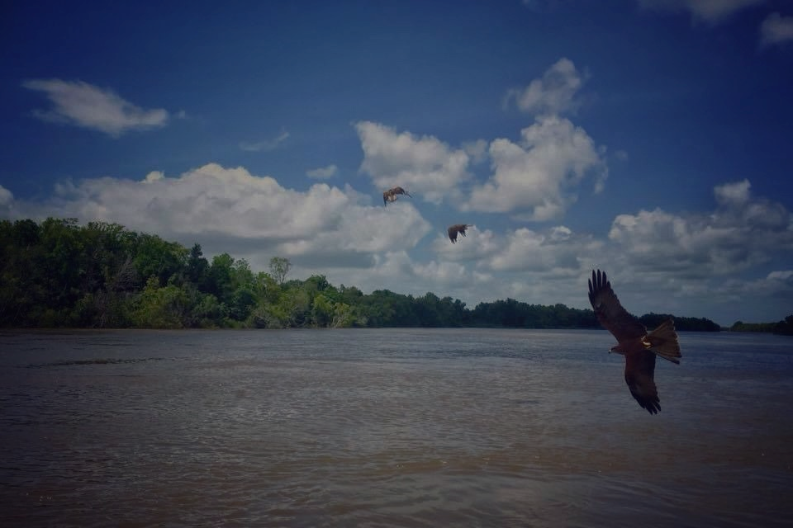
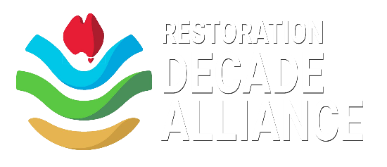
RDA Champion Application Form

The Restoration Decade Alliance (RDA) is a network of Australia’s restoration organisations and allied groups united in our collective efforts to support the goals of the UN Decade on Ecosystem Restoration.

Champions are small, on-ground restoration groups recognised by the RDA as contributing to Australia’s collective realisation of the objectives of the UN Decade on Ecosystem Restoration’s ambitious goals.

This special recognition of RDA Champions reflects the RDA’s appreciation of the fact that the work of every group – whatever its size – is critical to our collective effort.

Champions have no obligations to the RDA, but have the options to engage in the broader conversation around the UN Decade, connect and collaborate with the RDA, and use the RDA logo in their own promotion. Champions are encouraged to participate in reciprocal sharing of restoration stories to highlight actions undertaken in the UN Decade.

Champion groups have an opportunity to contribute to, collaborate with, and benefit from this outstanding alliance of Australian restoration organisations by:

- Promoting targeted action by Australian communities in the Decade; and
- Sharing best-practice knowledge.

Champion groups receive the following benefits:

- Email and newsletter communication of any collective RDA campaigns and communication initiatives;
- National amplification of the Champion organisation’s UN Decade-relevant stories and events through RDA social media; and,
- Use of RDA logo in promoting the Champion group’s projects that support the goals of the UN Decade on ER.

About your organisation

(a) Name of your organization:

(b) What ecosystem restoration activity does your organisation focus on?
(c) What is your organisation’s vision/mission?
(d) What is your organisation’s geographic scope?

2. Contact details and organisational information
(a) Primary contact name & email:

(b) “Cc’ Contact name & email:

(c) Comms contact name & email:

(d) Organisation website:

(e) Number of members in your organisation:

(f) Your organisation’s social media links:
Facebook:
Instagram:
Twitter:
TikTok:
LinkedIn:

3. Any other information about your organisation that you would like to share:

- Completed applications to be emailed to facilitator@restorationdecadealliance.org -

